Academic Impact

## A PROJECT REPORT

***Submitted by***

# Sarthak Shamra

***in partial fulfillment for the award of the degree of***

# BACHELOR OF COMPUTER APPLICATIONS

**IN**

UNIVERSITY INSTITUTE OF COMPUTING



**CHANDIGARH UNIVERSITY**

April, 2025



# BONAFIDE CERTIFICATE

Certified that this project report **Academic Impact** is the Bonafide work of

**Sarthak Sharma** who carried out the project work under my/our supervision.

### SIGNATURE

Dr. Kavita Gupta

Head of Department UIC BCA

### SIGNATURE

Miss.Nikita Singla

Project Supervisor

UIC BCA

Submitted for the project viva voce examination held on

**INTERNAL EXAMINER EXTERNAL EXAMINER**

# ACKNOWLEDGEMENT

The satisfaction that accompanies the successful completion of any task would be incomplete without the mention of people whose ceaseless cooperation made it possible, whose constant guidance and encouragement crown all efforts with success. On the submission of our thesis report on **Academic Impact**, we would like to extend our gratitude and sincere thanks to our supervisor **Ms. Nikita Singla**, Department of Computer Applications, for his constant motivation and support. We truly appreciate and value her esteemed guidance and encouragement from the beginning to the end of this thesis. I am indebted to her for having helped us shape the problem and providing insights into the solution. I want to thank my teacher **Ms. Nikita Singla** for providing a solid background for our studies and research thereafter. I am grateful to my supervisor for the guidance, inspiration and constructive suggestions that were helpful in the preparation of this project and its successful completion. She has been a great source of inspiration to me, and I thank her from the bottom of my heart. Above all, I would like to thank all my friends whose direct and indirect support helped me in the last month to go ahead with my Thesis. The thesis would have been impossible without their perpetual moral support.

**SARTHAK SHARMA – 22BCA10754**

# TABLE OF CONTENT

Abstract 05

CHAPTER 1. INTRODUCTION & DEMO AND CODE 06

CHAPTER 2. PROJECT OBJECTIVES 08

CHAPTER 3. TECHNOLOGIES IMPLEMENTED 09

CHAPTER 4. PROJECT FEATURES 10

CHAPTER 5. DEVELOPMENT PROCESS 11

CHAPTER 6. SCREENSHOTS 14

CHAPTER 6. CONCLUSION 16

# Abstract

This project, titled 'Academic Impact', analyzes the relationship between social media usage and the academic performance of students. Using Microsoft Excel, the project generates fictional data for 100 students, organizes it in a structured table ('Raw Data'), and presents analytical insights via a comprehensive Dashboard.

Graphs, such as scatter plots and line charts, illustrate the correlations between screen time, study time, and CGPA. The report outlines the methodology, challenges encountered, key observations, and future possibilities for research in data driven academic assessments.

# CHAPTER 1. INTRODUCTION & PROJECT DEMO

**Introduction:**

The modern academic environment is increasingly influenced by digital technology. This project investigates how various social media habits impact students' academic outcomes. Data interpretation techniques in Microsoft Excel are applied to explore relationships between screen time (across platforms like Instagram, YouTube, WhatsApp, Discord, Reddit), study hours, sleep patterns, and the corresponding effect on CGPA.

**Project Function:**

The project simulates data for 100 students with diverse profiles.  
 A centralized data sheet ('Raw Data') is used for storing student details and performance metrics.

A dedicated Dashboard sheet presents visual charts:  
 • Scatter Chart: Examines the correlation between Total Screen Time and CGPA.  
 • Line Chart: Displays the relationship between Study Time and CGPA.  
 • Pie Chart: Highlights the distribution of Co-curricular Participation.

The project shows how Excel formulas and charts can interpret data to draw

meaningful conclusions about academic performance.

# CHAPTER 2. PROJECT OBJECTIVES

**Primary Objective:**

To analyse the effect of social media usage on students' academic performance using data interpretation techniques in Microsoft Excel.

**Secondary Objectives:**

* To identify key correlations between screen time, study habits, sleep duration, and CGPA.  
   To demonstrate the use of Excel as a tool for data visualization and decision making.  
   To propose recommendations for students to balance digital engagement with academic responsibilities.  
   To lay the groundwork for future research incorporating real world data.

# CHAPTER 3. TECHNOLOGIES IMPLEMENTED

* **Microsoft Excel:** The primary tool used for data entry, manipulation, and analysis.
* **Excel Formulas:** Utilized for calculations such as AVERAGE, ROUND, and conditional logic to compute metrics like Total Screen Time and CGPA estimation.
* **Charts & Graphs:**
* Scatter Plot: For evaluating the correlation between screen time and academic performance.
* Line Chart: To track changes in CGPA relative to study hours.
* Pie Chart: For summarizing categorical data like co-curricular

participation.

* Pivot Tables & Dynamic Dashboards: Employed to present summarized, interactive views of the data for quick insights.

# CHAPTER 4. PROJECT FEATURES

* **Data Simulation:** 100 student records are generated with varying parameters (age, gender, social media usage, study time, etc.).
* **Dynamic Data Analysis:** Real time calculations determine key performance indicators (CGPA, total screen time, etc.) which update as data changes.
* **Visual Representation:** Graphical dashboards facilitate an intuitive understanding of trends and correlations.  
  **User friendly Layout:** The project features a neatly arranged 'Raw Data' sheet alongside a comprehensively designed Dashboard to enhance clarity.
* **Extensibility:** The project design allows for easy expansion, incorporating additional variables or transitioning to real world data collection.

# CHAPTER 5. DEVELOPMENT PROCESS

**Phase 1: Data Generation & Organization** • Simulated student data was generated using random values

in Excel.  
 • Data was organized systematically in a well-structured 'Raw Data' sheet.  
  
**Phase 2: Visualization & Dashboard Creation**

• Dynamic dashboards were created using Excel's charting tools.  
 • Key analytical metrics were computed using a combination of Excel

formulas.  
 • Initial tests ensured that charts updated automatically when new data was

added.  
  
**Phase 3: Analysis & Insight Generation** • Data analysis revealed notable trends, such as the negative correlation between high screen time and CGPA.  
 • Iterative improvements were made to enhance visual clarity and data readability.  
 **Phase 4: Documentation & Reporting**

• A detailed report was compiled to capture methodology, technologies, challenges, and insights.  
 • Emphasis was placed on future scope and potential expansions.

**Screenshots:**

* 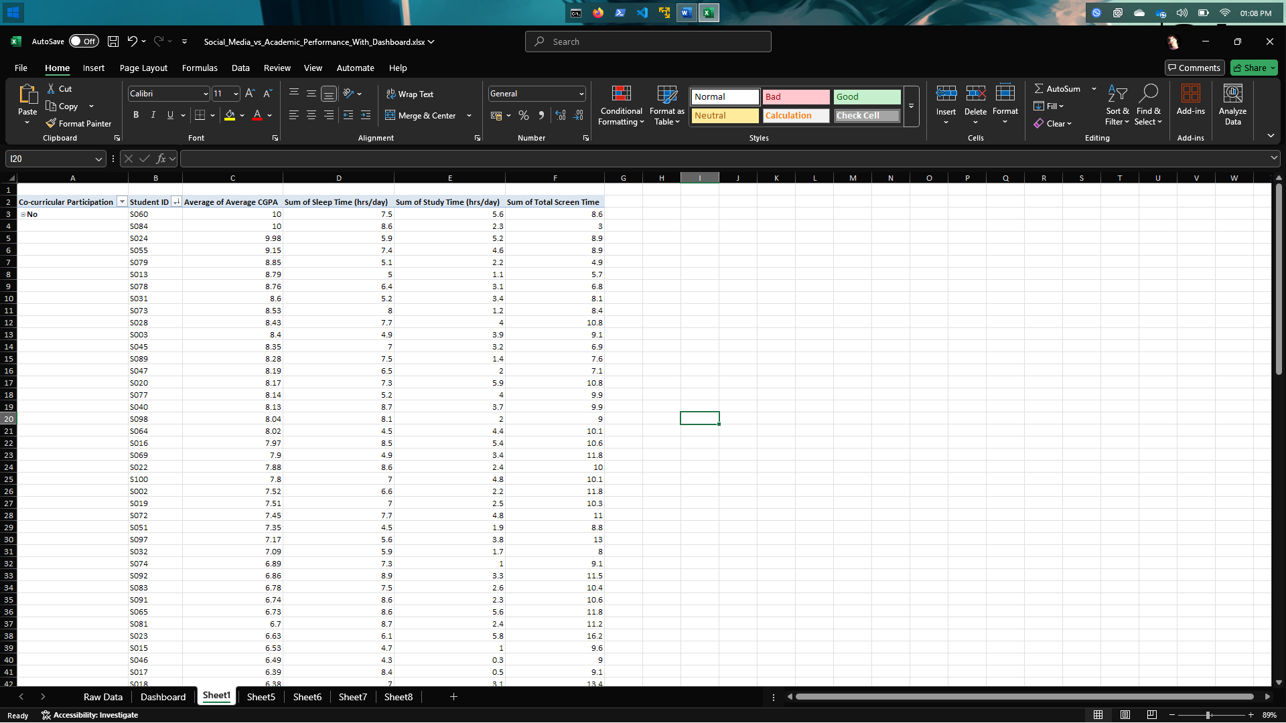Screenshot of **Pivot Table**
* 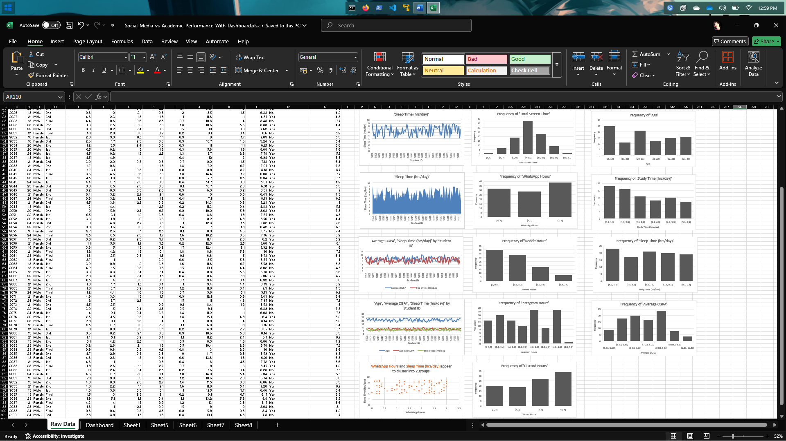Screenshot of **Raw Data** sheet

* A screenshot of a computer

  AI-generated content may be incorrect.Screenshot of **Dashboard**
* Charts: Scatter Plot (Screen Time vs CGPA), Line Chart (Study Time vs CGPA), Pie Chart (Co-curricular Distribution)

# CHAPTER 7. CONCLUSION

The 'Academic Impact' project successfully demonstrates the power of Microsoft Excel as an analytical tool. By simulating student behavior and academic performance, the project offers a clear view of how social media usage may influence learning outcomes. The dynamic dashboards, combined with interactive charts, provide valuable insights, emphasizing the need for balanced digital consumption. In conclusion, the project not only serves as a practical analysis but also establishes a foundation for future studies leveraging real world data.